**A PROJECT REPORT ON**

**“GYM MANAGEMENT SYSTEM”**

Submitted in Partial Fulfilment of

VI SEMESTER BCA

As Prescribed by

**INDIAN ACADEMY DEGREE COLLEGE**

**AUTONOMOUS**

Developed by

**SHOAIB KHAN**

Under the guidance of

**MR SHOAIB**

**CERTIFICATE**

This is to Certify that the Project entitled **“GYM MANAGEMENT SYSTEM**” is a bonafide work done by **SHOAIB KHAN** submitted in partial fulfilment of VI semester BCA as prescribed by the **INDIAN ACADEMY DEGREE COLLEGE AUTONOMOUS**, during the academic year **2023- 2024**

**Internal Guide Head of the Department**

Ms.Anuradha.P

**External Examiners:**

**1.**

**2.**

# ACKNOWLEDGEMENT

We take an opportunity to thank our respected chairman **Dr. T. Soma Shekar** for providing wonderful environment and excellent infrastructure.

We also take an opportunity to express our gratitude to our respected principal **Dr. N. Thilaka** , who installed root of inspiration to us.

We also express our gratitude to our respected HOD, **Ms. Anuradha P** for her constant cooperation for developing this project.

# DECLARATION

We **SHOAIB KHAN**  here by declare that this project work entitled **“GYM MANAGENT**

**SYSTEM”** is submitted to the Department of Computer Science, Indian Academy Degree CollegeAutonomous, Bangalore for partial fulfillment of the requirement for the award of Bachelor of Computer Application is a result of original work carried out by ourself. We further declare that we have not submitted this project report either in part or in full to any other university for the award for any degree

# ABSTRACT

The gym management system, developed using PHP, is a robust solution designed to revolutionize the management of gym operations and enhance customer experience. At its core, the system provides a comprehensive platform for administrators to efficiently handle various tasks, from customer registration to payment processing and exercise routine management. Through an intuitive admin panel, gym administrators can effortlessly register new customers, maintain their profiles, and manage payment records, including creating new payment plans and tracking payment histories. Additionally, administrators can curate personalized exercise routines tailored to individual customer needs and preferences, facilitating effective workout planning and goal tracking.

On the customer side, the system offers convenient access to payment records, personalized routines, and health progress tracking, empowering individuals to monitor their fitness journey and stay motivated towards their goals. With integrated health tracking features, customers can input and monitor key health metrics such as weight, height, calories, and fats, gaining valuable insights into their overall health and fitness status.

Overall, this gym management system aims to optimize gym operations, streamline communication between administrators and customers, and deliver a personalized and engaging fitness experience for all stakeholders

## Table of Content

|  |  |  |
| --- | --- | --- |
| **SL.NO** | **CONTENTS** | **PAGE NO.** |
| **01** | **Introduction**  1.1 Problem Definition  1.2 Scope of the Project  1.3 Objective of the project | **1-3** |
| **02** | **System Analysis**  2.1 Proposed System  2.2 System Requirement  2.2.1 Hardware Requirement  2.2.2 Software requirement | **4-5** |
| **03** | **System Design**  3.1 Database design  3.2 Architecture design  3.3 ER Diagram  3.4 DFD (Level 0, Level 1)  3.5 Use Case diagram for User & Admin | **6-18** |
| **04** | **Source Code and Screenshots**  4.1 Source code  4.2 screenshots | **19-72** |
| **05** | **Test Cases** | **73-74** |
| **06** | **Conclusion & Future Enhancement**  6.1 Conclusion  6.2 Future enhancement | **75** |
| **07** | **Bibliography** | **76-79** |

1. **INTRODUCTION TO PROJECT:**

Our fitness management system revolutionizes the way fitness services are administered and accessed. Through our Admin Panel, administrators effortlessly handle customer registrations, payments, health tracking, plan creation, trainer assignments, and overall record-keeping. On the User Panel, fitness enthusiasts enjoy seamless access to personalized trainer selections, diet plans, exercise charts, and subscription management. Our platform seamlessly bridges the gap between administrators and users, fostering a dynamic ecosystem where progress and support thrive. Welcome to a new era of fitness management, where efficiency meets empowerment.

* 1. **PROBLEM DEFINITION:**

Our Gym Management System is a gym and health club membership management system. You can keep records on your members, their memberships, and have quick and easy communication between you and your members. Gym Management also includes a booking system, point of sale, banking, accounting, concessions and has a range of reports that help in the management of your club. Our Gym Management System is a complete gym and recreation facility system program which looks after all of your members, memberships and activities. It is designed for gyms, recreation centers, and health clubs.

* 1. **SCOPE OF THE PROJECT:**

Moving on, this simple gym management system project in PHP focuses mainly on dealing with the customer regarding their payments, routines, records. Also, the system displays all the available data such as customer’s details with their respective payment amount, routines, and health status. The project contains an Admin Panel. In an overview of this web app, the admin has access to register customers as well as maintain their payment records. Talking more about the project, the admin can create new plans for the customer’s payment. In terms of health status, he/she has to update each and every customer’s profile with current weight, height, calories, fats, etc. Besides, the admin can also manage exercise routines up to a week’s routine.

On the other hand, an admin can view overall reports of their members under monthly reports and yearly reports. Also, he/she can view total income per month which displays the member’s name with id, gender, contact, payment date, expiry date, plan name, amount, and certain validity respectively. Lastly, the system allows the admin to update the profile which includes username, full name, and the user can change their password information too.

* 1. **OBJECTIVE OF THE PROJECT:**

1. **Efficient Customer Management**:

Develop a system that allows easy registration of new customers and efficient maintenance of their profiles, including contact information, payment records, and health metrics.

1. **Streamlined Payment Processing**:

Implement features for tracking customer payments, generating invoices, and managing payment schedules to ensure timely and accurate payment processing.

1. **Flexible Plan Creation**:

Create a system that enables the admin to create and manage various payment plans tailored to different customer needs, including membership tiers, pricing structures, and payment frequencies.

1. **Comprehensive Health Tracking**:

Develop functionality for tracking and updating customer health metrics, such as weight, height, calories burned, and body fat percentage, to provide a comprehensive view of each customer's health status.

1. **Personalized Exercise Routines**:

Design a system for creating and managing personalized exercise routines for customers, taking into account individual fitness goals, abilities, and progress tracking.

1. **User-Friendly Admin Panel**:

Develop an intuitive admin panel interface that provides easy access to all system functionalities, allowing the admin to efficiently manage customer interactions, payments, health tracking, and exercise routines.

1. **Data Security and Privacy**:

Implement robust security measures to protect customer data, including encryption of sensitive information and role-based access control to ensure that only authorized users can access and modify data.

1. **Scalability and Extensibility**:

Build a scalable and extensible system architecture that can accommodate future growth and evolving business requirements, allowing for easy integration of new features and enhancements.

By achieving these objectives, the gym management system will effectively streamline operations, enhance customer satisfaction, and improve overall efficiency in managing gym facilities and services.

1. **SYSTEM ANALYSIS:** 
   1. **PROPOSED SYSTEM:**

Our proposed fitness management system encompasses two distinct panels: the Admin Panel and the User Panel, each designed to streamline operations and enhance user experience within our fitness facility. The Admin Panel offers secure login capabilities with advanced authentication options for administrators, ensuring robust access control. Administrators can efficiently register new customers, assigning them unique IDs while managing payments seamlessly through integrated payment gateways, ensuring accurate transaction recording. Health status monitoring tools allow admins to track and update customer progress, while comprehensive plan management functionalities enable the creation and customization of fitness plans tailored to individual needs. Detailed reporting features provide insights into customer details and administrative activities, ensuring transparency and accountability. Admins can also create and manage exercise and diet routines, assign gym trainers, and maintain their own profile details effortlessly.

Conversely, the User Panel provides users with secure login functionalities and intuitive interfaces to select preferred trainers, view personalized diet plans, and manage subscription options conveniently. Users can access detailed profiles of assigned trainers, fostering clearer communication and engagement. Both panels are designed with mobile-friendly interfaces for accessibility on the go, supported by notifications for important updates and progress tracking tools to monitor fitness goals effectively. Our system aims to optimize administrative efficiency, enhance user satisfaction, and foster a supportive environment for achieving fitness objectives seamlessly.

* + - * Security of data.
      * Ensure Data accuracy’s.
      * Proper Control of the system.
      * Minimize manual data entry
      * Minimum time needed for the various processing • Greater efficiency.
      * Better service.
      * User friendly and interactive.
      * Minimum time required.

* 1. **SYSTEM REQUIREMENT:** 
     1. **Hardware requirements:**

|  |  |
| --- | --- |
| RAM | 8.00 GB |
| Hard disk | 1 TB |
| Processor | Intel(R) Core(TM) i5-7200U |
| Processing speed | CPU @ 2.50GHz 2.70 GHz |

* + 1. **Software Requirements:**

|  |  |
| --- | --- |
| Front end | HTML AND CSS BOOTSTARPS |
| Back end | PHP,SQL |
| Tools | Microsoft words tools |
| Operating System | Microsoft Windows 10 |

1. **SYSTEM DESIGN:**

To design a simple gym management system, we'll need to outline the architecture, databases, and functionalities for both the admin and user panels. Here's a breakdown:

1. **Database Design:**
   * **Admin Database:** Stores admin credentials and activity logs.
   * **Customer Database:** Stores customer details, health status, payment history, and assigned trainers.
   * **Trainer Database:** Stores trainer details and availability.
2. **System Components:**

* **Admin Panel:**
  + **Login Module:** Authenticates admin using username and password.
  + **Customer Management:** Allows admin to register customers, manage customer details, and assign trainers.
  + **Payment Module:** Enables admin to process payments, track transactions, and manage subscription plans.
  + **Health Status Tracking:** Provides tools to monitor and update customer health status based on training progress.
  + **Plan Management:** Allows admin to create, update, and manage training plans.
  + **Routine Management:** Facilitates the creation and management of exercise or diet routines.
  + **Reports:** Generates reports on customer details, payments, and admin activities.
  + **Admin Profile:** Allows admin to view and edit their profile, including changing login credentials.
  + **Insert Trainer:** Admin can add gym trainer and assign the trainer for customer
* **User Panel:** 
  + **Login Module:** Secure login for users using credentials provided by the admin.
  + **Trainer Selection:** Allows users to choose their preferred trainer from available options.
  + **Diet and Exercise Plans:** Provides access to diet plans and exercise routines assigned by the admin.
  + **Subscription Management:** Allows users to update their subscription plans.
  + **Trainer-User Assignment Display:** Displays images of assigned trainers for users for better visualization.

1. **Security Considerations:**
   * + **Secure Authentication:** Use encryption techniques for storing passwords and secure login mechanisms.
     + **Data Protection:** Implement role-based access control to restrict access to sensitive data.
     + **Secure Transactions:** Use secure protocols for handling payment transactions.
     + **Regular Backups:** Implement regular database backups to prevent data loss.

▪

1. **User Interface Design:**
   * + Design intuitive and user-friendly interfaces for both admin and user panels.
     + Utilize responsive design principles for accessibility across different devices.
2. **Scalability and Performance:**
   * + Design the system to handle a growing number of customers, admins, and trainers efficiently.
     + Optimize database queries and system processes for better performance.
3. **Testing and Maintenance:**
   * + Conduct thorough testing to ensure the reliability and functionality of the system.
     + Implement regular maintenance to address bugs, updates, and user feedback.

**3.1 DATABASE DESIGN**

The data in the system has to be stored and retrieved from database. Designing the database is part of system design. Data elements and data structures to be stored have been identified at analysis stage. They are structured and put together to design the data storage and retrieval system.

A database is a collection of interrelated data stored with minimum redundancy to serve many users quickly and efficiently. The general objective is to make database access easy, quick, inexpensive and flexible for the user. Relationships are established between the data items and unnecessary data items are removed. Normalization is done to get an internal consistency of data and to have minimum redundancy and maximum stability. This ensures minimizing data storage required, minimizing chances of data inconsistencies and optimizing for updates. The MySQL database has been chosen for developing the relevant databases.

**TABLE STRUCTURE:**

* **Address table:** This table can be used to store addresses of members within the gym management system, It provides a structured way to store address information, facilitating efficient data management and retrieval.

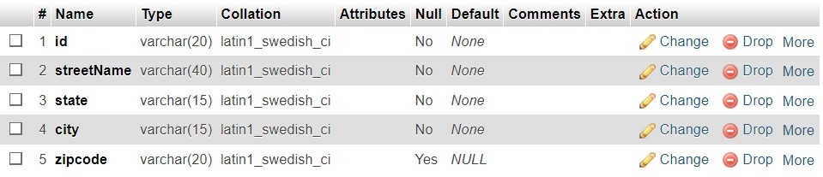

* **Admin table:** This table can be used to store information about administrators or staff members who have access to the gym management system.

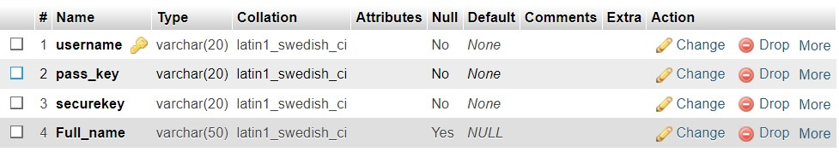

* **payment:** This table can be used to track all payments made by gym members. By associating payments with member IDs, it allows for easy retrieval of payment history for individual members. Storing the payment amount, date, and method provides a comprehensive record of financial transactions within the gym management system

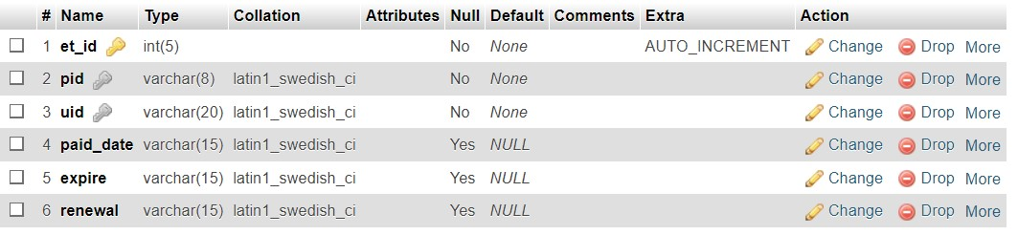

* **Health Status table:** This table allows the gym management system to track and analyze the health progress of members over time, helping them to set fitness goals, monitor their health status, and provide personalized fitness plans and recommendations.

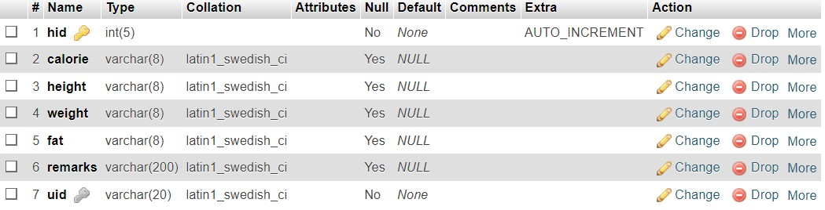

* **Images:** you can store images related to gym members, such as profile pictures, progress photos, or any other relevant images within the gym management system.

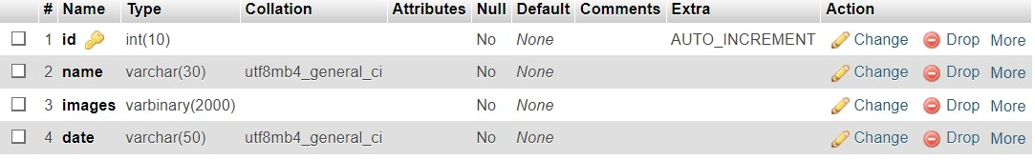

* **Subscription plan:** This table allows you to store information about different subscription plans offered by the gym, including their names, descriptions, prices, durations, and whether they are currently active or not. You can use this data to manage subscription offerings, track memberships, and calculate revenue.

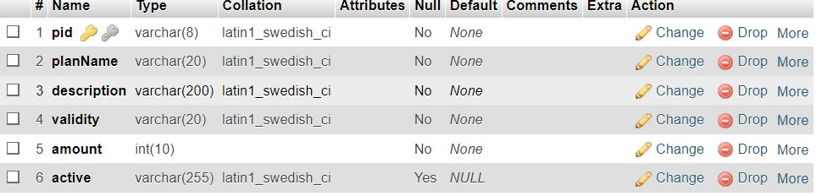

* **routines:** This table allows you to store information about various workout routines offered by the gym

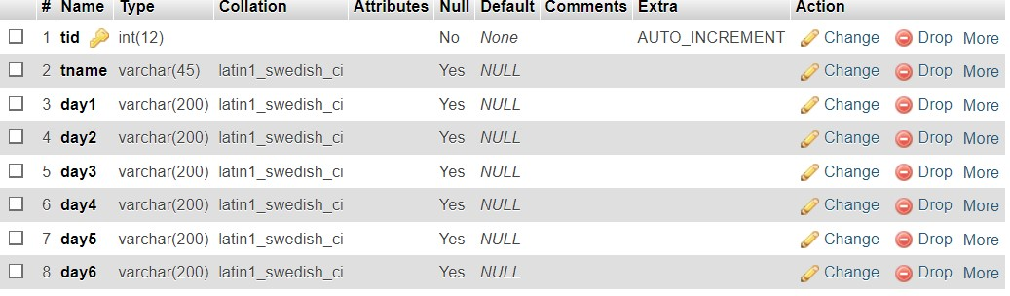

* **User Registration table:** This table allows you to store information about gym members, including their personal details, contact information, registration date, and active status. You can use this data to manage member accounts, track memberships, and provide personalized services to gym members.

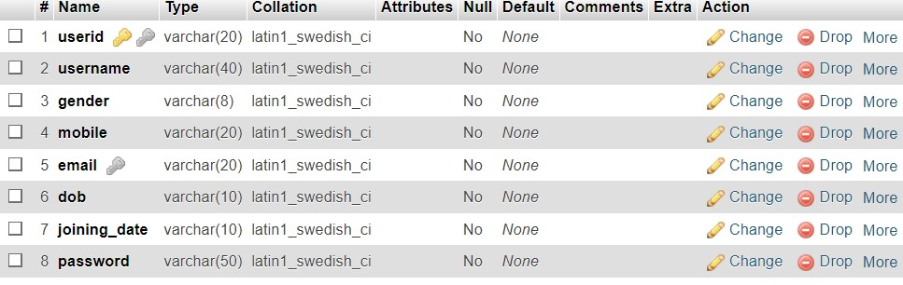

* 1. **ARCHITECTURE SYSTEM:**

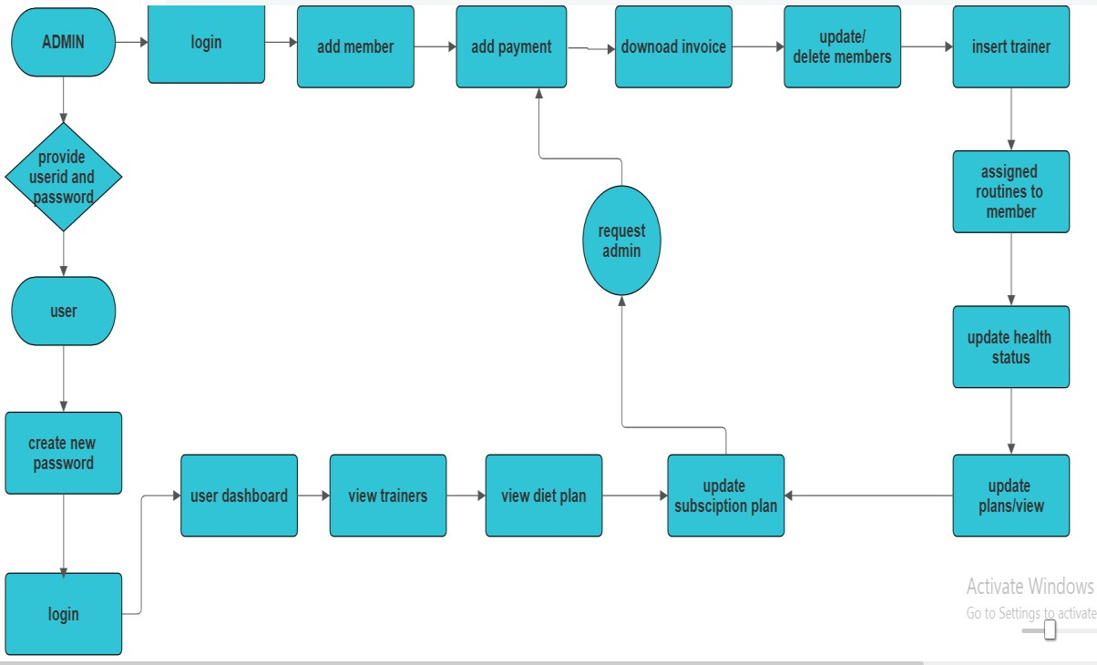

* 1. **E-R DIAGRAM FOR GYM MANAGEMENT SYSTEM:**

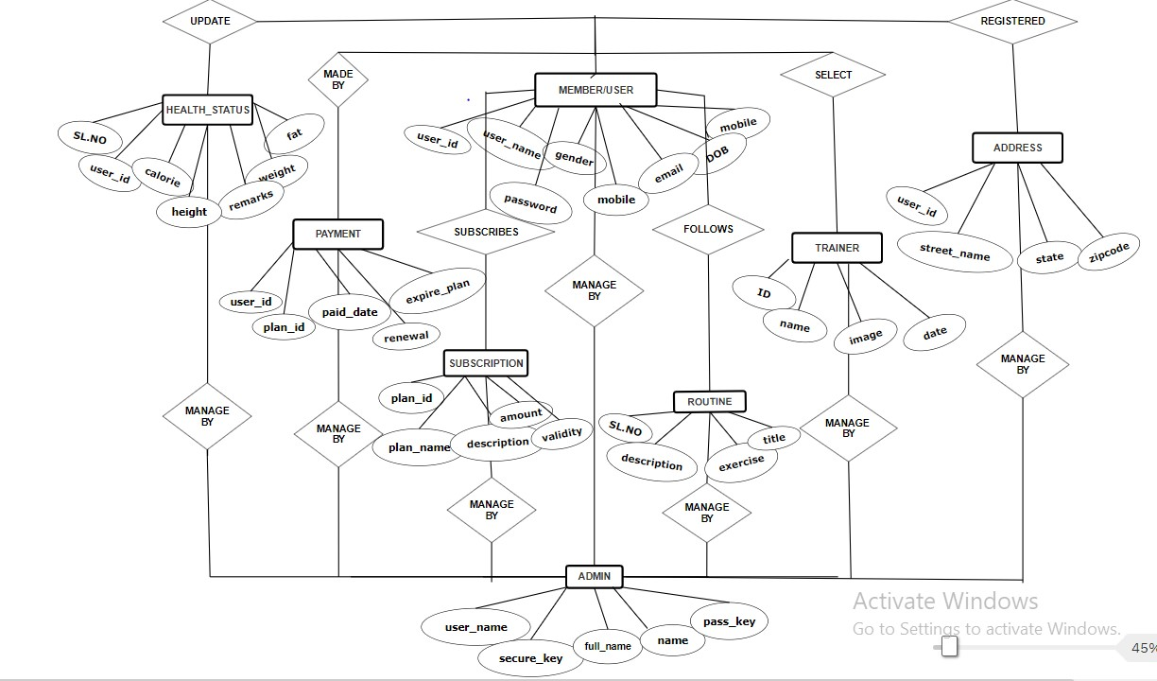

* 1. **DATA FLOW DIAGRAM (level 0 and level 1):**

The Data Flow Diagrams (DFDs) are used for structure analysis and design. DFDs show the flow of data from external entities into the system. DFDs also show how the data moves and are transformed from one process to another, as well as its logical storage. The following

**Level 0 DFD/Context Diagram:**

A Level 0 context diagram provides an overview of the entire system, showing interactions between the system (the gym management system, in this case) and external entities. Here's a simplified version of a Level 0 context diagram for a gym management system:

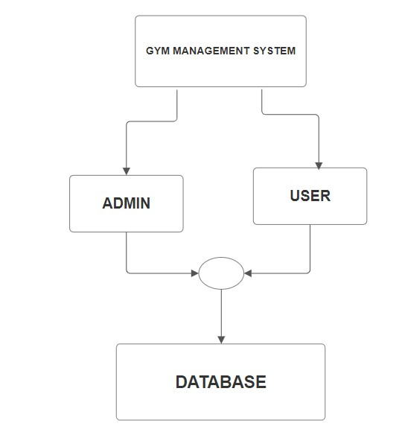

* + - **Gym Management System**: Represents the main system entity.
    - **Admin Panel**: Interface for admin-related functionalities.
    - **User Panel**: Interface for user-related functionalities.
    - **Database**: Stores data related to admin, users, payments, health status, plans, routines, trainers, etc.

This Level 0 DFD provides a high-level overview of the gym management system, showing the main external entities (admin and user panels) and their interaction with the system. The database serves as the central repository for storing and managing data associated with the system's functionalities.

**Level 1 DFD:**

Level 1 Data Flow Diagram (DFD) elaborating on the functionalities within the admin and user panels of the gym management system:

**USER:**

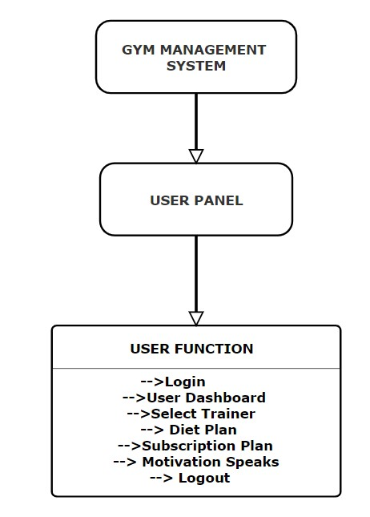

* + - **User Panel**: This entity represents the user interface for gym members.
    - **User Functions**: These are the functions available within the user panel, including login, selection of trainers, viewing diet plans and managing subscription plans

* + - **ADMIN:**

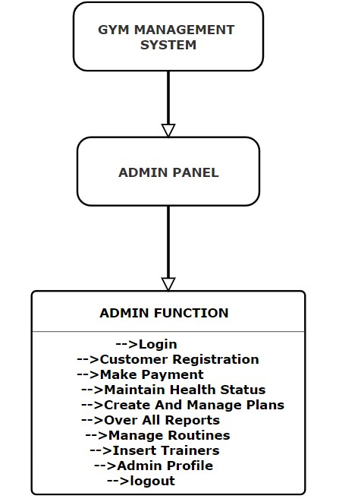

* + - **Admin Panel**: This entity represents the administrative interface of the gym management system.
    - **Admin Functions**: These are the specific functions available within the admin panel, including login, customer registration, payment processing, health status management, plan creation and management, reporting, routine management, trainer insertion, and profile management.

**3.5 Use Case Diagram For User And Admin:**

A use case diagram provides a high-level overview of the interactions between actors (users) and the system. Here's a breakdown of the use case diagram for the described system:

**ADMIN:**

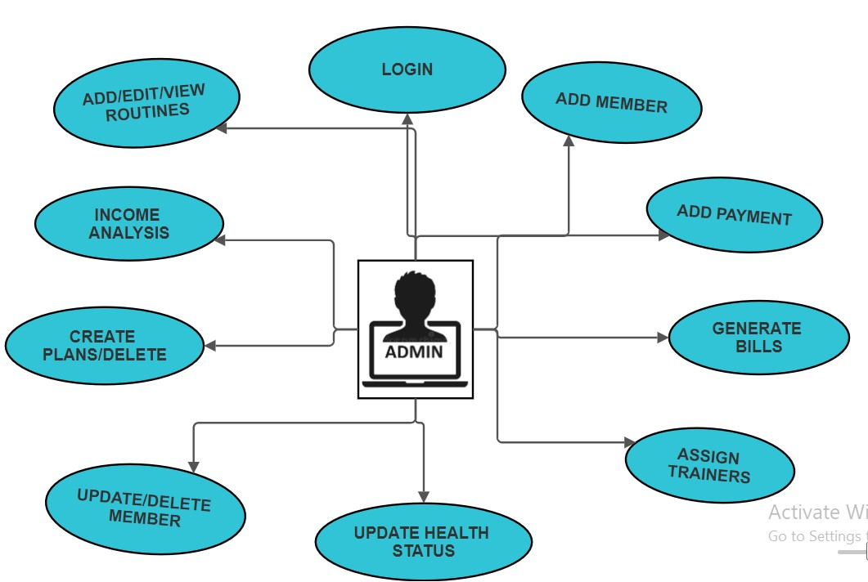

• **Use Cases for Admin Panel:**

1. **Admin Panel Login**: Secure login for the admin using username and password.
2. **Customer Registration**: Ability to register customers with automatically generated IDs.
3. **Make Payments**: Admin can register and process payments on behalf of customers, with transaction details recorded.
4. **Maintain Health Status**: Tracking and updating the health status of customers based on their training progress.
5. **Create and Manage Plans**: Admin can manage existing plans and create new ones for customers.
6. **Overall Reports**: Keeping records of customer details and admin activities.
7. **Manage Routines**: Creating and managing exercise or diet routines for customers.
8. **Insert Trainer**: Adding gym trainers and assigning them to customers.
9. **Admin Profile**: Viewing and editing admin profile details, including changing credentials like password and username.

▪ **USER:**

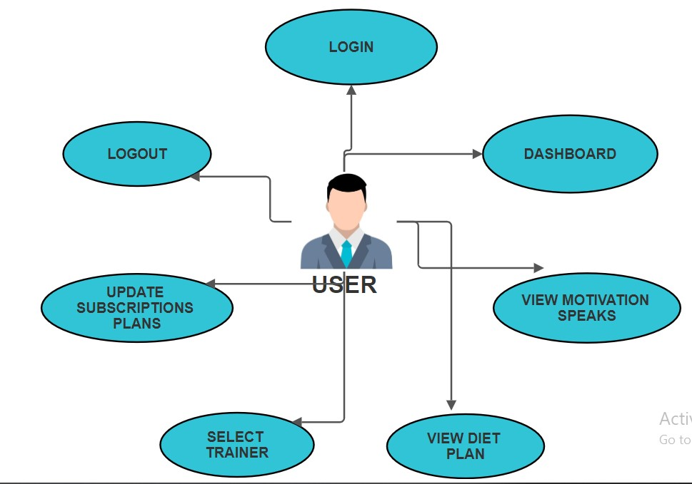

**Use Cases for User Panel:**

1. **User Panel Login**: Secure login for users using credentials provided by the admin.
2. **Select Trainer**: Ability for users to choose their preferred trainer.
3. **Diet Plan**: Viewing diet plans and exercise charts provided by the admin.
4. **Subscription Plan**: Users can update their subscription plans.
5. **View Assigned Trainer (Not explicitly mentioned)**: Users can view images of assigned trainers, suggesting a visual representation of trainer-user assignments within the system.

Each of these use cases represents a specific action or functionality within the system. The interactions between the actors and the system are depicted through these use cases, providing a clear understanding of the system's capabilities from both admin and user perspectives.

1. **SOURCE CODES AND SCREENSHOTS:**

**4.1 SOURCE CODE :**

• **Home Page:**

<!DOCTYPE html>

<html lang="en">

<head>

<title>GYM</title>

<meta charset="UTF-8">

<meta name="viewport" content="width=device-width, initial-scale=1">

<link rel="stylesheet" href="https://www.w3schools.com/w3css/4/w3.css">

<link rel="stylesheet" href="https://fonts.googleapis.com/css?family=Lato">

<link rel="stylesheet" href="https://cdnjs.cloudflare.com/ajax/libs/font-awesome/4.7.0/css/font-awesome.min.css">

<style> body {font-family: "Lato", sans-serif}

.mySlides {display: none}

.container { position: relative; width: 100%; max-width: 400px;

}

.container img { width: 100%; height: auto;

} body { font-family: Arial, sans-serif; margin: 0; padding: 0; } body { margin: 0; padding: 0; background: linear-gradient(90deg,white,yellow); /* Specify the path to your background image */ background-size: cover; /* Cover the entire background */ background-image:url('images/b.png'); background-repeat:repeat-x;background-size:100%100%;

}

.container { max-width: 800px; margin: 50px auto; } table { width: 100%; border-collapse: collapse;

}

}

</style>

</head>

<body>

<!-- Navibar -->

<div class="w3-top">

<div class="w3-bar w3-black w3-card">

<a class="w3-bar-item w3-button w3-padding-large w3-hide-medium w3-hide-large w3-right" href="javascript:void(0)" onclick="myFunction()" title="Toggle Navigation Menu" class="w3-black"><i class="fa fa-bars"></i></a>

<a href="#" class="w3-bar-item w3-button w3-padding-large" style="color:gold;"><b>HOME</b></a>

|  |  |  |  |
| --- | --- | --- | --- |
| <a href="userlogin.php" class="w3-bar-item style="color:gold;"><b>Userlogin</b></a> | w3-button | w3-padding-large | w3-hide-small" |
| <a href="index.php" class="w3-bar-item style="color:gold;"><b>AdminLogin</b></a> | w3-button | w3-padding-large | w3-hide-small" |
| <a href="#band1" class="w3-bar-item | w3-button | w3-padding-large | w3-hide-small" |

style="color:gold;"><b>OFFERS</b></a>

<a href="#band3" class="w3-bar-item w3-button w3-padding-large w3-hide-small"style="color:gold;"><b>JOIN NOW!!</b></a>

<a href="#band" class="w3-bar-item w3-button w3-padding-large w3-hide-small" style="color:gold;"><b> ABOUT GYM!!</b></a>

<div class="w3-dropdown-hover w3-hide-small">

<button class="w3-padding-large w3-button" title="More" style="color:gold;"><b>MORE</b> <i class="fa facaret-down"></i></button>

<div class="w3-dropdown-content w3-bar-block w3-card-4">

<a href="#contact" class="w3-bar-item w3-button">CONTACT US</a>

<a href="#help" class="w3-bar-item w3-button">Help?</a>

</div>

</div>

<a href="javascript:void(0)" class="w3-padding-large w3-hover-red w3-hide-small w3-right"><i class="fa fasearch"></i></a>

</div>

</div>

</header>

<!-- Navbar on small screens (remove the onclick attribute if you want the navbar to always show on top of the content when clicking on the links) -->

<div id="navDemo" class="w3-bar-block w3-black w3-hide w3-hide-large w3-hide-medium w3-top" style="margin-top:46px" >

<a href="#band1" class="w3-bar-item w3-button w3-padding-large" onclick="myFunction()">BAND1</a>

<a href="#band3" class="w3-bar-item w3-button w3-padding-large" onclick="myFunction()">BAND3</a>

<a href="#tour" class="w3-bar-item w3-button w3-padding-large" onclick="myFunction()">TOUR</a>

<a href="#band" class="w3-bar-item w3-button w3-padding-large" onclick="myFunction()">BAND</a>

<a href="#contact" class="w3-bar-item w3-button w3-padding-large" onclick="myFunction()">CONTACT</a>

<a href="#help" class="w3-bar-item w3-button w3-padding-large" onclick="myFunction()">Help?</a>

</div>

<!-- Page content -->

<div class="w3-content" style="max-width:2000px;margin-top:46px">

<!-- Automatic Slideshow Images -->

<div class="mySlides w3-display-container w3-center ">

<img src="images/h1.png" style="width:100%">

<div class="btn1">

</div>

<div class="w3-display-abstrbottommiddle w3-container w3-text-white w3-padding-32 w3-hide-small">

<h3 style="color:black;"><b>NO PAIN NO GAIN!!</h3></b>

<p style="color:white;"><b>¨The only person you are destined to become is the person you decide to be.¨ – Ralph

Waldo Emerson!</b></p>

</div>

</div>

<div class="mySlides w3-display-container w3-center">

<img src="images/h2.png" style="width:100%">

<div class="btn1">

</div>

<div class="w3-display-bottommiddle w3-container w3-text-white w3-padding-32 w3-hide-small">

<h3 style="color:black;"><b>Don't Wish For It Work For It</b></h3>

<p style="color:white;"><b>“Once you learn to quit, it becomes a habit.¨ ― Vince Lombardi Jr.</b></p>

</div>

</div>

<div class="mySlides w3-display-container w3-center">

<img src="images/h5.png" style="width:110%">

<div class="btn1">

</div>

<div class="w3-display-bottommiddle w3-container w3-text-white w3-padding-32 w3-hide-small">

<h3 style="color:black;"><b>GO Hard Go Home</b></h3>

<p style="color:white;"><b>¨A year from now you may wish you had started today.¨ – Karen Lamb</b></p>

</div>

<script>

// Automatic Slideshow - change image every 3 seconds var myIndex = 0; carousel();

function carousel() { var i;

var x = document.getElementsByClassName("mySlides");

for (i = 0; i < x.length; i++) { x[i].style.display = "none";

}

myIndex++; if (myIndex > x.length) {myIndex = 1} x[myIndex-1].style.display = "block"; setTimeout(carousel, 3000);

}

// Used to toggle the menu on small screens when clicking on the menu button function myFunction() { var x = document.getElementById("navDemo"); if (x.className.indexOf("w3-show") == -1) {

x.className += " w3-show";

} else {

x.className = x.className.replace(" w3-show", "");

}

}

// When the user clicks anywhere outside of the modal, close it var modal = document.getElementById('ticketModal'); window.onclick = function(event) { if (event.target == modal) { modal.style.display = "none";

}

}

</script>

</div><br><br><br><br>

<!-- The offers Section -->

<div class="w3-container w3-content w3-center w3-padding-64" style="max-width:1000px;" id="band1"> <div class="container">

<h2><b>Gym Membership Plans</b></h2>

<h3>-------------------SPECIAL OFFERS-------------------</h3>

<table>

<thead>

<tr>

<th>Plan</th>

<th>Description</th>

<th>Original Price</th>

<th>Discounted Price</th>

</tr>

</thead>

<tbody>

<tr>

<td>monthly plan</td>

<td>Per Month</td>

<td class="original-price"><del>&#8377;1833</del></td>

<td class="discounted-price">&#8377;1500</td>

</tr>

<tr>

<td>Basic</td>

<td>Three Months</td>

<td class="original-price"><del>&#8377;6000</del></td>

<td class="discounted-price">&#8377;5500</td>

</tr>

<tr>

<td>Standard</td>

<td>Six Months</td>

<td class="original-price"><del>&#8377;12000</del></td>

<td class="discounted-price">&#8377;11500</td>

</tr>

<tr>

<td>Premium</td>

<td>Twelve Months</td>

<td class="original-price"><del>&#8377;24000</del></td>

<td class="discounted-price">&#8377;23500</td>

</tr>

</tbody>

</table>

</div><br/><br/><br/>

<!---APPLY FORM section--->

<div class="w3-container w3-content w3-center w3-padding-64" style="max-width:800px;" id="band3">

<div class="contact-container">

<form action="https://api.web3forms.com/submit/" method="POST" id="form" class="contact-left" > <input type="hidden" name="redirect" value="http://localhost/Gym-System/thank_you.html"> <div class="contact-left-title">

<h2><b>APPLY</b></h2>

<hr>

<p style="color:red;"><strong><b>Important Note:</b></p style="color:black;"><p></strong> Please fill out the form below to apply for membership at our gym.</p>

</div>

<input type="hidden" name="access_key" value="db386e0d-fbdb-4650-84b5-53fbb142fecf">

<b>EMAIL:</b><input type="email" class="contact-inputs" name="email" placeholder="Enter your Email:" required>

<b>NAME:</b><input type="text" class="contact-inputs" name="name" placeholder="Enter Name:" required>

<b>STREET:</b><input type="text" class="contact-inputs" name="streetname" placeholder="Enter Street Name:" required>

<b>CITY:</b><input type="text" class="contact-inputs" name="city" placeholder="Enter City " required>

<b>ZIPCODE:</b><input type="text" class="contact-inputs" name="code" placeholder="Enter your Zipcode: " required>

<b>STATE:</b> <input type="text" class="contact-inputs" name="state" placeholder="Enter State" required>

<b>GENDER:</b>

<select name="gender" class="contact-inputs" required="">

<option value="">--Please Select--</option>

<option value="Male">Male</option>

<option value="Female">Female</option>

</select>

<b>DATE OF BIRTH:</b><input type="date" name="dob" class="contact-inputs" required="" placeholder="enter your Date Of Birth">

<b>PHONE NO:</b><input type="number" name="mobile" class="contact-inputs" maxlength="10" placeholder="Enter Your Mobile Number:" required="" >

<b>JOINING DATE:</b><input type="date" class="contact-inputs" name="jdate" required="" placeholder="Choose Joining Date:">

<b>MEMBERSHIP PLAN:</b><select name="plan" required="" class="contact-inputs" onchange="myplandetail(this.value)">

<option value="">--Please Select--</option>

<option value="23500">Twelve Months</option><option value="11500">Six Months</option><option value="1500">Monthly Plan</option><option value="5500">Three Months</option> </select>

<b>MESSAGE</b><textarea name="message" class="contact-inputs" cols="30" rows="10" placeholder="Enter Message:" required></textarea>

<!-- Add a hidden input field to specify the redirect URL -->

<button type="submit" class="contact-inputs" >submit <img src="\Gym-system\images\arrow_icon.png" alt=""></button> <script> window.onload = function() {

// Reset the form fields when the page loads document.getElementById("form").reset();

};

</script>

</form>

</div><br><br>

<!-- The gym Section -->

<div class="w3-container w3-content w3-center w3-padding-64" style="max-width:800px" id="band">

<h1><b>About Gym Fitness</b></h1>

<p><b>Gym fitness is an integral component of a holistic approach to health and well-being. It encompasses a wide range of physical activities and exercises designed to improve overall fitness levels and promote a healthier lifestyle. Within the dynamic environment of a gym, individuals have access to a diverse array of equipment and resources tailored to meet their specific fitness goals, whether they aim to build strength, increase endurance, enhance flexibility, or achieve weight loss. Weightlifting, cardio exercises, functional training, and group fitness classes are just a few examples of the activities available in a gym setting.</b></p>

<p><b>Besides the physical benefits, gym fitness offers numerous mental and emotional advantages. Engaging in regular exercise releases endorphins, often referred to as "feel-good" hormones, which can help alleviate stress, anxiety, and depression. Moreover, the social aspect of gym environments fosters a sense of community and camaraderie among members, providing invaluable support and motivation on the fitness journey. Whether one prefers the solitary focus of a solo workout or the energizing atmosphere of group classes, the gym accommodates various preferences and fitness levels.</b></p>

<p><b>Moreover, gym fitness is adaptable to individual needs and schedules, making it accessible to people of all ages and backgrounds. From busy professionals seeking a quick workout during lunch breaks to retirees looking to maintain mobility and vitality, the gym offers flexibility in both time and intensity of exercise. Additionally, many gyms provide expert guidance from certified personal trainers who can create personalized workout plans, offer nutritional advice, and ensure proper form and technique to maximize results while minimizing the risk of injury.</b></p>

<p><b>In conclusion, gym fitness is not merely about physical exercise; it's a lifestyle choice that promotes holistic well-being encompassing physical, mental, and emotional health. By incorporating regular gym sessions into their routines, individuals can experience improved fitness levels, heightened mood, reduced stress, and enhanced overall quality of life.</b></p>

</div>

<div class="w3-row w3-padding-32">

<div class="w3-third">

<p>WORK</p>

<img src="images/workout2.jpg" class="w3-round w3-margin-bottom" alt="Random Name" style="width:60%">

</div>

<div class="w3-third">

<p>FOR</p>

<img src="images/workout3.jpg" class="w3-round w3-margin-bottom" alt="Random Name" style="width:60%">

</div>

<div class="w3-third">

<p>IT</p>

<img src="images/workout4.jpg" class="w3-round" alt="Random Name" style="width:60%">

</div>

</div>

</div><br><br><br><br>

<!-- The Contact Section -->

<div class="w3-container w3-content w3-padding-64" style="max-width:800px" id="contact">

<h2 class="w3-wide w3-center"><b>CONTACT US</b></h2>

<p class="w3-opacity w3-center"><i>Fan? Drop a note!</i></p>

<div class="w3-row w3-padding-32">

<div class="w3-col m6 w3-large w3-margin-bottom">

<i class="fa fa-map-marker" style="width:30px"></i> Bangalore, India<br>

<i class="fa fa-phone" style="width:30px"></i> Phone: +91 8310525907<br>

<i class="fa fa-envelope" style="width:30px"> </i> Email: uf7113884@gmail.com<br>

</div><br/>

</div><br><br><br><br><br><br><br><br>

<div class="w3-container w3-content w3-padding-64" style="max-width:800px" id="help">

<h2><b>HELP TO REACH US:</b></h2>

<h4>Location & Directions:</h4>

<p>We are located at:</p>

<iframe src="https://www.google.com/maps/embed?pb=!1m18!1m12!1m3!1d3887.0869773270483!2d77.63300407489405! 3d13.030132987290614!2m3!1f0!2f0!3f0!3m2!1i1024!2i768!4f13.1!3m3!1m2!1s0x3bae16e4871b7ab7%3A0xb98 c353d4262b37d!2sIndian%20Academy%20Degree%20College%20-

%20Autonomous!5e0!3m2!1sen!2sin!4v1713803643687!5m2!1sen!2sin" width="200" height="200"

style="border:20" allowfullscreen="" loading="lazy" referrerpolicy="no-referrer-when-downgrade"></iframe> <address>

230, Hennur Main Rd,

Meganahalli, Kalyan Nagar,

Bengaluru, Karnataka 560043

</address>

<h4>OR</h4>

<p>If you need further assistance, please feel free to contact us at</p>

<a href="https://wa.me/8310525907">Message on WhatsApp</a>

</div><br/><br/><br/><br/><br/><br/><br>

<br><br>

<!-- Footer -->

<footer class="w3-container w3-padding-64 w3-center w3-opacity w3-dark-grey w3-xlarge w3-ylarge"> <div>

<h2 class="w3-wide"><b>DEVELOPED BY</b></h2>

<p class="w3-opacity w3-center"><i>#personal contact</i></p>

<div class="w3-row w3-padding-32">

<a href="https://wa.me/8310525907">UMAR FAROOQ</a><br>

<a href="https://wa.me/9900470026">SHOIAB PASHA</a><br>

<a href="https://wa.me/9739636931">SYED TAHIR</a>

</div>

<i class="fa fa-facebook-official w3-hover-opacity"></i>

<i class="fa fa-pinterest-p w3-hover-opacity"></i>

<i class="fa fa-twitter w3-hover-opacity"></i>

<i class="fa fa-linkedin w3-hover-opacity"></i>

<p class="w3-medium"><b>Powered by </b><a href="https://www.w3schools.com/w3css/default.asp" target="_blank">w3.css</a></p>

</footer>

</body>

</html>

• **User login:**

<!DOCTYPE html>

<html lang="en">

<head>

<meta charset="UTF-8">

<meta http-equiv="X-UA-Compatible" content="IE=edge">

<meta name="viewport" content="width=device-width, initial-scale=1.0">

<title>UserLogin</title>

<style>

@import url('https://fonts.googleapis.com/css?family=Raleway:400,700');

* { box-sizing: border-box; margin: 0; padding: 0; font-family: Raleway, sans-serif;

} body { background-image:url('images/h1.png'); background-repeat:repeat-x;background-size:100%100%;/* Define the linear gradient */ height: 100vh; /* Set the height of the background to fill the viewport */ margin: 0; /* Remove default margin */ display: flex; justify-content: center; align-items: center; text-align: center;

} h1, p { color:#00FFFF; /* Set text color to white */

} h2 { color:gold; /* Change this to your desired text color */

} .container { display: flex; align-items: center; justify-content: center; min-height: 100vh;

}

.screen { background: linear-gradient(90deg, #5D54A4, #7C78B8); position: relative; height: 600px;

width: 360px; box-shadow: 0px 0px 24px #5C5696;

} .screen__content { z-index: 1; position: relative; height: 100%;

}

.screen__background { position: absolute; top: 0; left: 0; right: 0; bottom: 0; z-index: 0; -webkit-clip-path: inset(0 0 0 0); clip-path: inset(0 0 0 0); }

.screen_background_shape { transform: rotate(45deg); position: absolute; }

.screen_background_shape1 { height: 520px; width: 520px; background:#0000; top: -50px; right: 120px; border-radius: 0 72px 0 0;

}

.screen_background_shape2 { height: 220px; width: 220px; background:#FFD700; top: -172px; right: 0; border-radius: 32px;

}

.screen_background_shape3 { height: 540px; width: 190px; background: linear-gradient(270deg, #FFD700,#0000); top: -24px; right: 0; border-radius: 32px;

}

.screen_background_shape4 { height: 400px; width: 200px; background:#FFD700;

top: 420px; right: 50px; border-radius: 60px; }

.login { width: 320px; padding: 30px; padding-top: 156px; } .login__field { padding: 20px 0px; position: relative; } .login__icon { position: absolute; top: 30px; color: #7875B5;

} .login__input { border: none; border-bottom: 2px solid #D1D1D4; background: none; padding: 10px; padding-left: 24px; font-weight: 700;

width: 75%;

transition: .2s; }

.login__input:active,

.login__input:focus, .login__input:hover { outline: none; border-bottom-color: #6A679E;

} .login__submit { background: #fff; font-size: 14px; margin-top: 30px; padding: 16px 20px; border-radius: 26px; border: 1px solid #D4D3E8; text-transform: uppercase; font-weight: 700; display: flex; align-items: center; width: 100%; color: #4C489D; box-shadow: 0px 2px 2px #5C5696; cursor: pointer; transition: .2s;

.login__submit:active,

.login__submit:focus, .login__submit:hover { border-color: #6A679E; outline: none; } .button__icon { font-size: 24px; margin-left: auto; color: #7875B5;

} .social-login { position: absolute; height: 140px; width: 160px; text-align: center; bottom: 0px; right: 0px; color: #fff; } .social-icons { display: flex; align-items: center; justify-content: center; .social-login__icon { padding: 20px 10px; color: #fff; text-decoration: none; text-shadow: 0px 0px 8px #7875B5;

} .social-login__icon:hover { transform: scale(1.5); } .admin{

float:right; text-decoration:none; font-size:19px; color:navy; text-decoration: underline; font-weight:900; padding:2%; margin-top:1%;

}

.admin:hover{ color:; position:relative; left:5%; top:5px;

</style>

</head>

<body> <?php

session_start();

?>

<!--USER-LOGIN DESIGN -->

<div class="container">

<div class="screen">

<div class="screen__content">

<form class="login" action="" method="POST">

<h2 color="white">USERLOGIN</h2>

<div class="login__field">

<i class="login__icon fas fa-user"></i>

<input type="text" class="login__input" name="user" placeholder="User id">

</div>

<div class="login__field">

<i class="login__icon fas fa-lock"></i>

<input type="password" class="login__input" name="pass" placeholder="password"> </div>

<input type="submit" class="button login__submit" value="Login Now" name =

"submit"/><br><br><br><br><br><br>

<a href="homepage.php" class="admin">HOME PAGE</a>

</form>

</div>

<div class="screen__background">

<img src="images/workout4.jpg" class="w3-round">

<span class="screen_backgroundshape screenbackground_shape4"></span>

<span class="screen_backgroundshape screenbackground_shape3"></span>

<span class="screen_backgroundshape screenbackground_shape2"></span> <span class="screen_backgroundshape screenbackground_shape1"></span>

</div>

</div>

</div>

<!--USER CREDIENTAL DATA STORAGE-->

<?php if($_POST)

{

$user = $_POST['user']; $pass = $_POST['pass']; include ('include/db_conn.php'); if(mysqli_connect_errno()) { die("Failed to connect with MySQL: ". mysqli_connect_error());

}

$sql = "select * from users where userid='$user' AND password = '$pass' ";

$q= mysqli_query($con,$sql); $row = mysqli_fetch_array($q); if ($row > 0){

$_SESSION['un'] = $row[1];

$_SESSION['uid'] =$user; $id = $row[0]; if($row [7] == 'gms@123'){ echo"<script> window.location.href = 'changepassword.php?id=".$id."';

</script>"; } else{ echo"<script> window.location.href = '/Gym-System/userdashboard.php'

</script>"; } die(); } else{ echo"<script>alert('FAILED')</script>";

}

}

?>

</body>

</html>

• **User Dashboard:**

<!DOCTYPE html>

<html lang="en">

<head>

<link rel="stylesheet" href="https://use.fontawesome.com/releases/v5.8.1/css/all.css">

<meta charset="UTF-8">

<meta http-equiv="X-UA-Compatible" content="IE=edge">

<meta name="viewport" content="width=device-width, initial-scale=1.0">

<link rel="stylesheet" href="sidebars.css">

<title>Document</title>

<style>

@mport url('https://fonts.googleapis.com/css2?family=Open+Sans&display=swap');

.heading{ padding:1%; background-image: linear-gradient(to bottom right,gold,black);

} h4{ font-size: 20px; padding: 2%;

} .content div{ background-color:grey; margin:2%; padding: 1%;

}

.content div:nth-child(odd){ background-color:grey;

}

</style>

</head>

<body> <?php

session_start(); if(!isset( $_SESSION['un'] )){ echo "<script> alert('Please Login') </script>"; header("Location:userlogin.php");

}

?>

<div class="wrapper">

<!--Top menu -->

<div class="sidebar">

<div class="profile"> <img src="images/workout2.jpg" alt="profile_picture">

<h3><b><?php echo $_SESSION['un']; ?></b></h3>

</div>

<ul>

<li>

<a href="userdashboard.php" class="active">

<span class="icon"><i class="fas fa-home"></i></span>

<span class="item"><b>HOME</b></span>

</a>

</li>

<li>

<a href="usertrainer.php" >

<span class="icon"><i class="fas fa-burn"></i></span>

<span class="item "><b>Trainer</b></span>

</a>

</li>

<li>

<a href="usersubscription.php">

<span class="icon"><i class="fas fa-user"></i></span>

<span class="item"><b>Update plan</b></span>

</a>

</li>

<li>

<a href="diet.php">

<span class="icon"><i class="fas fa-chart-line"></i></span>

<span class="item"><b>Diet Plan</b></span>

</a>

</li>

<li>

<a href="furniture.php">

<span class="icon"><i class="fas fa-couch"></i></span>

<span class="item">FURNITURE</span>

</a>

</li>

<li>

<a href="#">

<span class="icon"><i class="fas fa-database"></i></span>

<span class="item">POST ADS</span>

</a>

</li>

<li>

<a href="#">

<span class="icon"><i class="fas fa-chart-line"></i></span>

<span class="item">Reports</span>

</a>

</li>

<li>

</li>

<li>

<a href="logout.php">

<span class="icon"><i class="fas fa-cog"></i></span>

<span class="item"><b>Logout</b></span>

</a>

</li>

</ul>

<!--menu item-->

</div>

</div>

<div class="major-content">

<h1 class="heading" ><b>GYM FITNESS!!</b></h1>

<div class='content'>

<div>

<h4>“Success usually comes to those who are too busy to be looking for it.”</h4>

<p>-Henry David Thoreau.</p>

</div>

<div>

<h4>“If you don’t make time for exercise, you’ll probably have to make time for illness.”</h4>

<p> -Robin Sharma</p>

</div>

</div>

</div>

</body>

</html>

• **Admin Login:**

<!DOCTYPE html>

<html>

<head>

<meta charset="UTF-8">

<meta http-equiv="X-UA-Compatible" content="IE=edge">

<meta name="viewport" content="width=device-width, initial-scale=1.0" >

<title>AdminLogin</title>

<style> a{ color:blue;

}

@import url('https://fonts.googleapis.com/css?family=Raleway:400,700');

* { box-sizing: border-box; margin: 0; padding: 0; font-family: Raleway, sans-serif;

} body { background-image:url('images/h2.png'); background-repeat:repeat-x;background-size:100%100%;

/* Define the linear gradient */ height: 100vh; /* Set the height of the background to fill the viewport */ margin: 0; /* Remove default margin */ display: flex; justify-content: center; align-items: center; text-align: center;

} h1, p { color:black; /* Set text color to white */

} h2 { color:blue; /* Change this to your desired text color */ } .container { display: flex; align-items: center; justify-content: center; min-height: 100vh;

}

.screen { background: linear-gradient(90deg, #5D54A4, #7C78B8); position: relative; height: 600px; width: 360px; box-shadow: 0px 0px 24px #5C5696;

} .screen__content { z-index: 1; position: relative; height: 100%;

}

.screen__background { position: absolute; top: 0; left: 0; right: 0; bottom: 0;

z-index: 0; -webkit-clip-path: inset(0 0 0 0); clip-path: inset(0 0 0 0); }

.screen_background_shape { transform: rotate(45deg); position: absolute; }

.screen_background_shape1 { height: 520px; width: 520px; background:#0000; top: -50px; right: 120px; border-radius: 0 72px 0 0; }

.screen_background_shape2 { height: 220px; width: 220px; background:#FFD700; top: -172px; right: 0; border-radius: 32px; }

.screen_background_shape3 { height: 540px; width: 190px; background: linear-gradient(270deg, #FFD700,#0000); top: -24px; right: 0; border-radius: 32px;

}

.screen_background_shape4 { height: 400px; width: 200px; background:#FFD700; top: 420px; right: 50px; border-radius: 60px;

}

.login { width: 320px; padding: 30px; padding-top: 50px; } .login__field { padding: 20px 0px; position: relative; }

.login__icon {

position: absolute; top: 30px; color: #7875B5;

} .login__input{ border: none; border-bottom: 2px solid #D1D1D4; background: none; padding: 10px; padding-left: 24px; font-weight: 700; width: 75%;

transition: .2s; } form { max-width: 500px; margin: 100px auto; padding: 100px; border: 0px dark black; background-color:linear-gradient(270deg,blue,black);

}

.login__input:active,

.login__input:focus, .login__input:hover { outline: none; border-bottom-color:black; } .login__submit { background: #fff; font-size: 14px; margin-top: 30px; padding: 16px 20px; border-radius: 26px; border: 1px solid #D4D3E8; text-transform: uppercase; font-weight: 700; display: flex; align-items: center; width: 100%; color: #4C489D; box-shadow: 0px 2px 2px #5C5696; cursor: pointer; transition: .2s; }

.login__submit:active,

.login__submit:focus, .login__submit:hover { border-color: #6A679E; outline: none; }

.button__icon { font-size: 24px; margin-left: auto; color: black; }

.social-login { position: absolute; height: 140px; width: 160px; text-align: center; bottom: 0px; right: 0px; color: #fff; } .social-icons { display: flex; align-items: center; justify-content: center; } .social-login__icon { padding: 20px 10px; color:black; text-decoration: none; text-shadow: 0px 0px 8px #7875B5; } .social-login__icon:hover { transform: scale(1.5); } .admin{

float:right; text-decoration:none; font-size:19px; color:blue; text-decoration: underline; font-weight:900; padding:2%; margin-top:1%;

}

.admin:hover{ color:; position:relative; left:5%; top:5px; } header { padding: 0px; text-align: center; }

.logo-small {

width: 80px; /* Adjust the width as needed for the small logo */

}

</style>

</head>

<body> <?php

session_start(); if(isset($_SESSION["user_data"]))

{ header("location:./dashboard/admin/");

}

?>

<div class="container">

<div class="screen">

<div class="screen__content">

<form class="login" action="secure_login.php" method='post' id="bb">

<h2 style="color:gold;">ADMIN LOGIN</h2>

<div class="login__field">

<i class="login__icon fas fa-user"></i>

<input type="text" placeholder="User ID" class="login__input" name="user_id_auth" id="textfield" data-ruleminlength="6" data-rule-required="true">

</div>

<div class="login__field">

<i class="login__icon fas fa-lock"></i>

<input type="password" name="pass_key" id="pwfield" class="login__input" data-rule-required="true" data-ruleminlength="6" placeholder="Password">

</div>

<input type="submit" name="submit" value="Login Now" class="button login__submit"><br><br>

<i class="entypo-login"></i>

<div class="login-bottom-links">

<a href="forgot_password.php" class="link">Forgot your password?</a><br>

<a href="homepage.php" class="admin">HOME PAGE</a>

</div>

</form>

</div>

<div class="screen__background">

<img src="images/workout4.jpg" class="w3-round">

<span class="screen_backgroundshape screenbackground_shape4"></span>

<span class="screen_backgroundshape screenbackground_shape3"></span>

<span class="screen_backgroundshape screenbackground_shape2"></span> <span class="screen_backgroundshape screenbackground_shape1"></span>

</div>

</div>

</div>

</body>

</html>

• **Admin Dashboard:**

<?php

require '../../include/db_conn.php'; page_protect(); ?>

<!DOCTYPE html>

<html lang="en">

<head>

<title>Gym | Dashboard </title>

<link rel="stylesheet" href="../../css/style.css" id="style-resource-5">

<script type="text/javascript" src="../../js/Script.js"></script>

<link rel="stylesheet" href="../../css/dashMain.css">

<link rel="stylesheet" type="text/css" href="../../css/entypo.css">

<style>

.page-container .sidebar-menu #main-menu li#dash > a { background-color: #533E85;

color: #ffffff; }

.sidebar-menu{

background-color:#533E85;

}

</style>

</head>

<body class="page-body page-fade" onload="collapseSidebar()">

<div class="page-container sidebar-collapsed" id="navbarcollapse">

<div class="sidebar-menu">

<header class="logo-env">

<!-- logo -->

<!-- logo collapse icon -->

<div class="sidebar-collapse" onclick="collapseSidebar()">

<a href="#" class="sidebar-collapse-icon with-animation"><!-- add class "with-animation" if you want sidebar to have animation during expanding/collapsing transition -->

<i class="entypo-menu"></i>

</a>

</div>

</header>

<?php include('nav.php'); ?>

</div>

<div class="main-content">

<div class="row">

<!-- Profile Info and Notifications -->

<div class="col-md-6 col-sm-8 clearfix">

</div>

<!-- Raw Links -->

<div class="col-md-6 col-sm-4 clearfix hidden-xs">

<ul class="list-inline links-list pull-right">

<li class="text-light"><b>Welcome</b> <b><?php echo $_SESSION['full_name']; ?></b>

</li>

<li>

<a href="logout.php" class="text-light"><b>Log Out</b><i class="entypo-logout right"></i>

</a>

</li>

</ul>

</div>

</div>

<h2 class="text-light" style="color:black;"><b>Admin Dashboard</b></h2>

<hr>

<div class="col-sm-3"><a href="revenue_month.php">

<div class="tile-stats tile-red">

<div class="num" data-postfix="" data-duration="1500" data-delay="0">

<h2><b>Income</b></h2>

<?php date_default_timezone_set("Asia/Calcutta");

$date = date('Y-m');

$query = "select * from enrolls_to WHERE paid_date LIKE '$date%'";

//echo $query;

$result = mysqli_query($con, $query);

$revenue = 0; if (mysqli_affected_rows($con) != 0) { while ($row = mysqli_fetch_array($result, MYSQLI_ASSOC)) {

$query1="select * from plan where pid='".$row['pid']."'";

$result1=mysqli_query($con,$query1); if($result1){

$value=mysqli_fetch_row($result1);

$revenue = $value[4] + $revenue;

} echo "".$revenue;

?>

</div>

</div></a>

</div>

<div class="col-sm-3"><a href="table_view.php">

<div class="tile-stats tile-green">

<div class="num" data-postfix="" data-duration="1500" data-delay="0">

<h2><b>Total Members</b></h2>

<?php

$query = "select COUNT(*) from users";

$result = mysqli_query($con, $query);

$i = 1; if (mysqli_affected_rows($con) != 0) { while ($row = mysqli_fetch_array($result, MYSQLI_ASSOC)) { echo $row['COUNT(*)'];

}

}

$i = 1;

?>

</div>

</div></a></div>

<div class="col-sm-3"><a href="over_members_month.php">

<div class="tile-stats tile-aqua">

<div class="num" data-postfix="" data-duration="1500" data-delay="0">

<h2><b>New Members</b></h2>

<?php date_default_timezone_set("Asia/Calcutta");

$date = date('Y-m');

$query = "select COUNT(*) from users WHERE joining_date LIKE '$date%'";

//echo $query;

$result = mysqli_query($con, $query);

$i = 1; if (mysqli_affected_rows($con) != 0) { while ($row = mysqli_fetch_array($result, MYSQLI_ASSOC)) { echo $row['COUNT(*)'];

}

$i = 1;

?> </div> </div></a> </div>

<div class="col-sm-3"><a href="view_plan.php">

<div class="tile-stats tile-blue">

<div class="num" data-postfix="" data-duration="1500" data-delay="0">

<h2><b>Available Plans</b></h2>

<?php

$query = "select COUNT(*) from plan where active='yes'";

//echo $query;

$result = mysqli_query($con, $query);

$i = 1; if (mysqli_affected_rows($con) != 0) { while ($row = mysqli_fetch_array($result, MYSQLI_ASSOC)) { echo $row['COUNT(*)'];

}

}

$i = 1;

?>

</div>

</div></a>

</div>

<?php include('footer.php'); ?>

</div>

</body>

</html>

**4.2 SCREENSHOTS:**

**homepage:**



**Admin Login:**



**Admin Dashboard:**

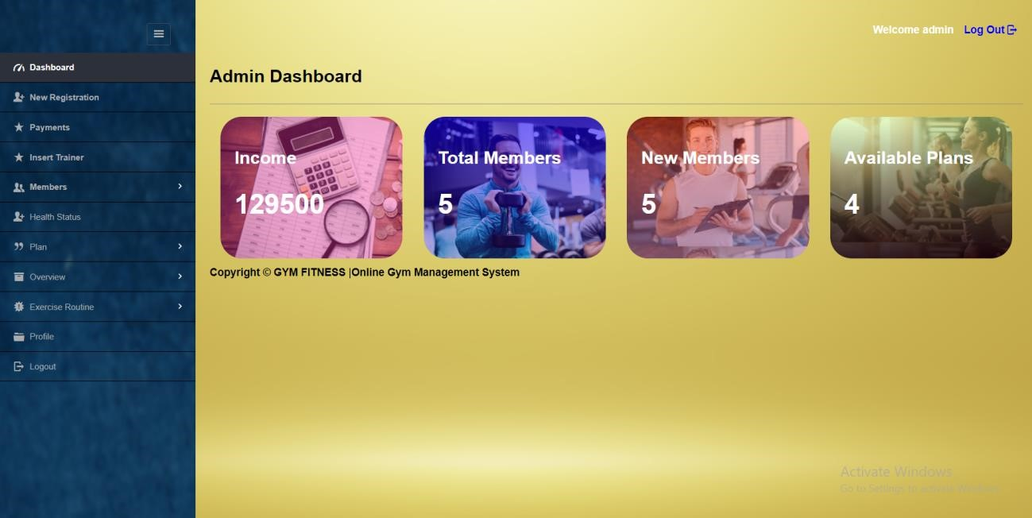

**Admin Add Users:**

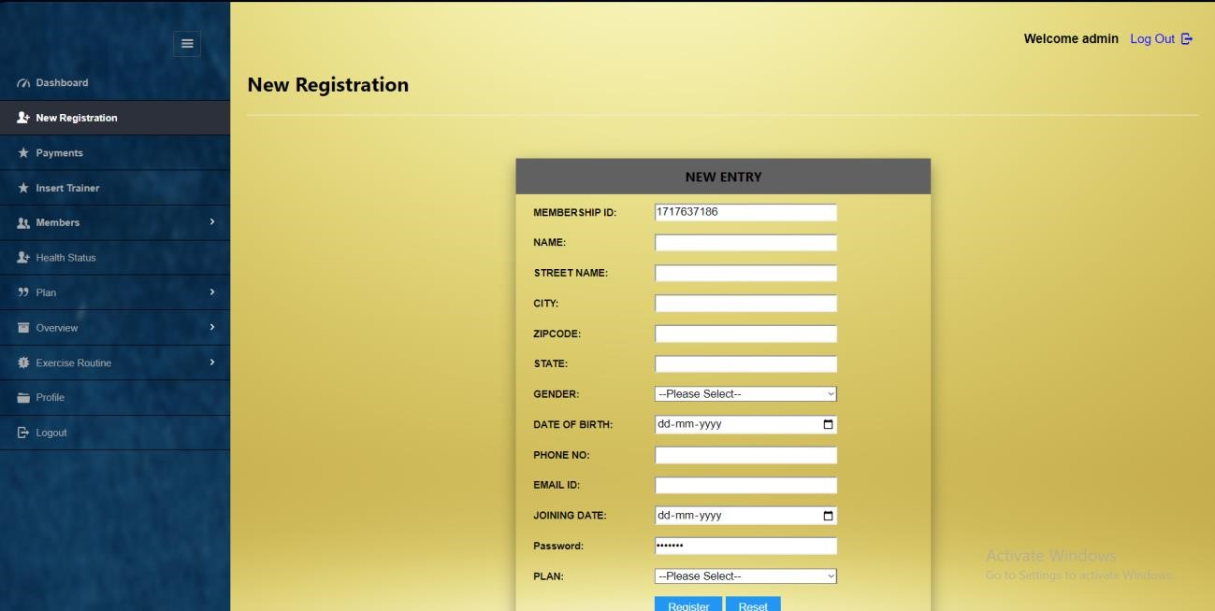

**Payment Registration:**

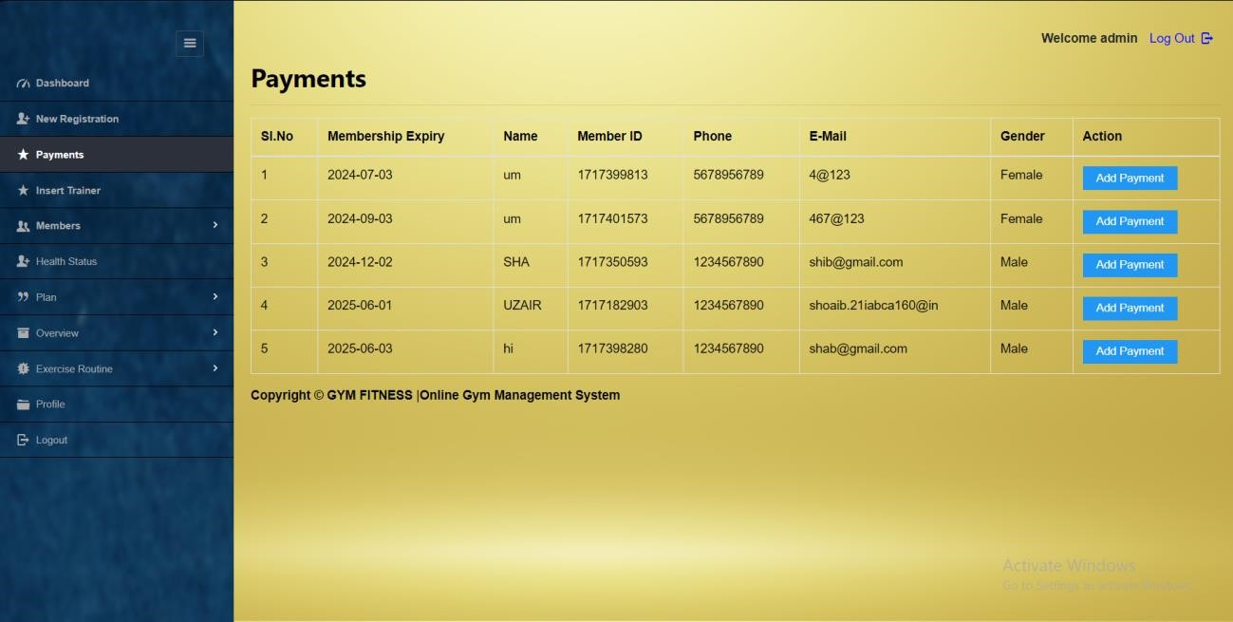

**Select Trainer:**

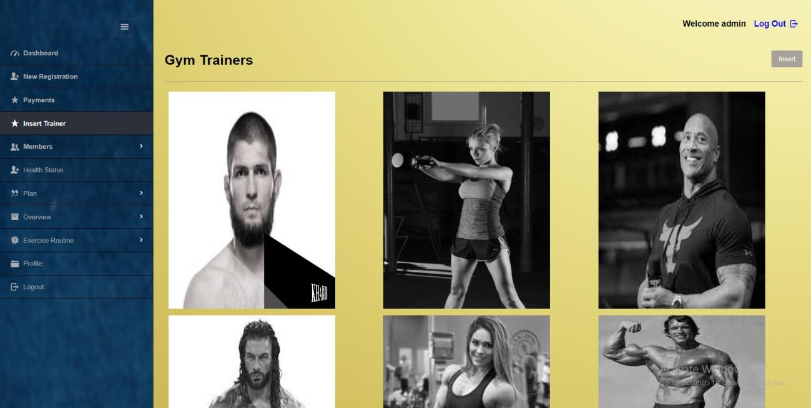

**Member Details:**

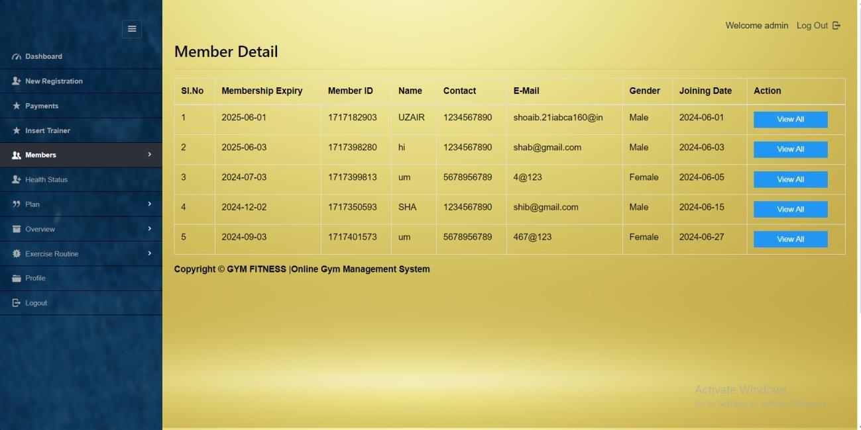

**Income Per Month:**

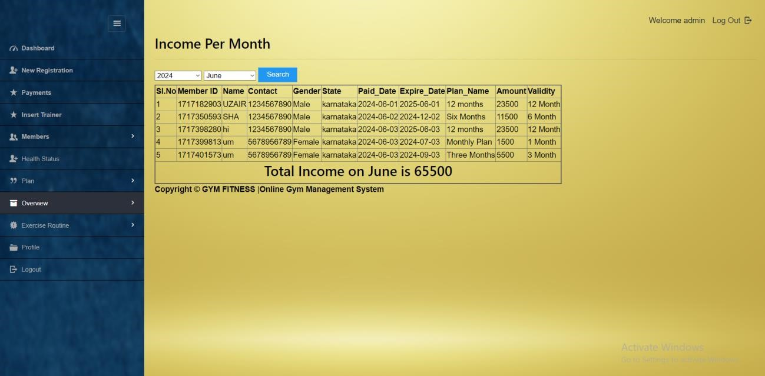

**Health status:**

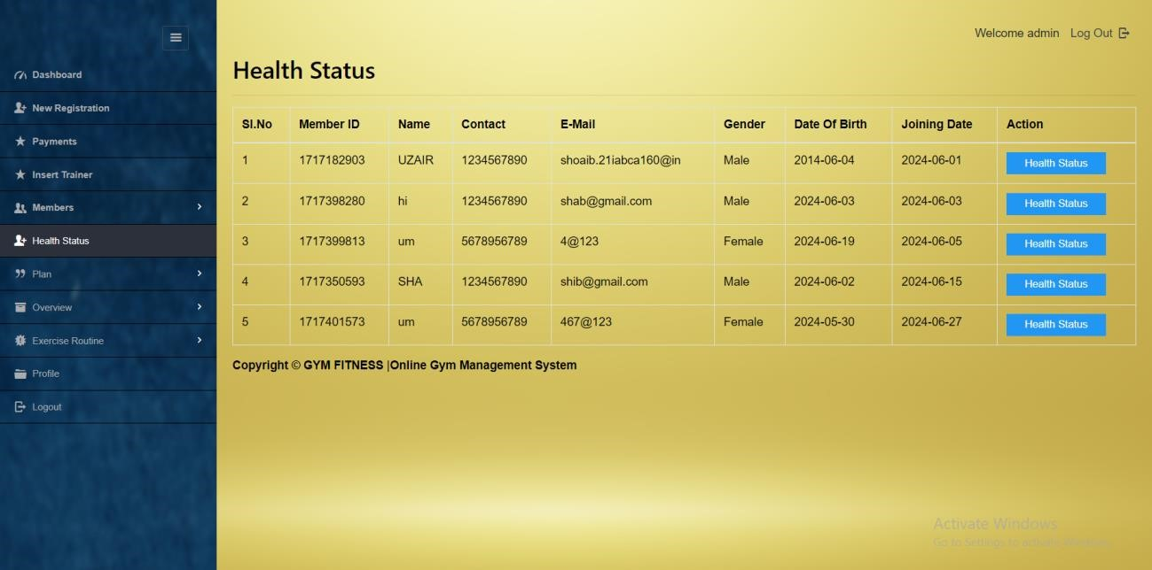

**Manage Plans:**

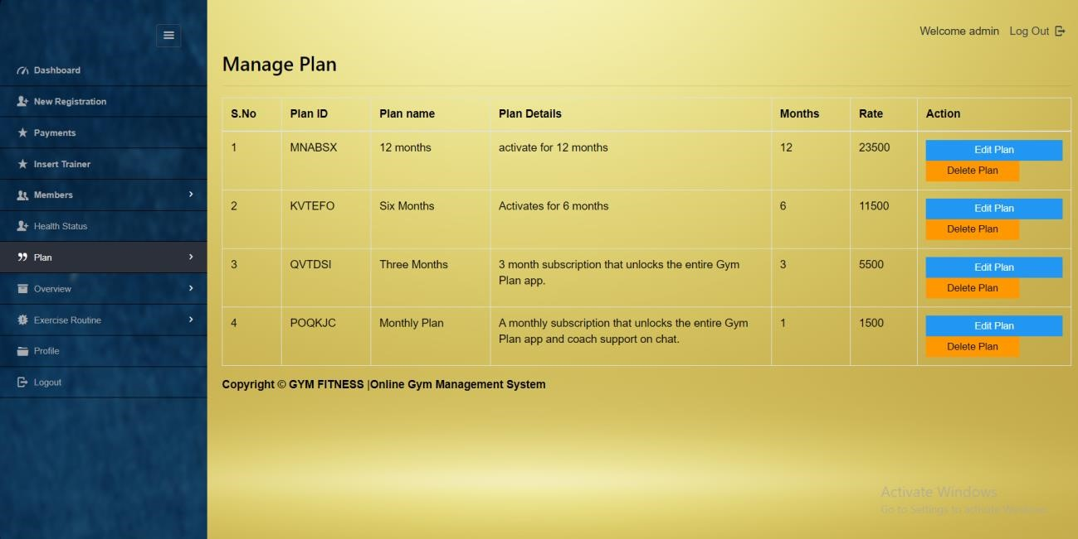

**Admin profile:**

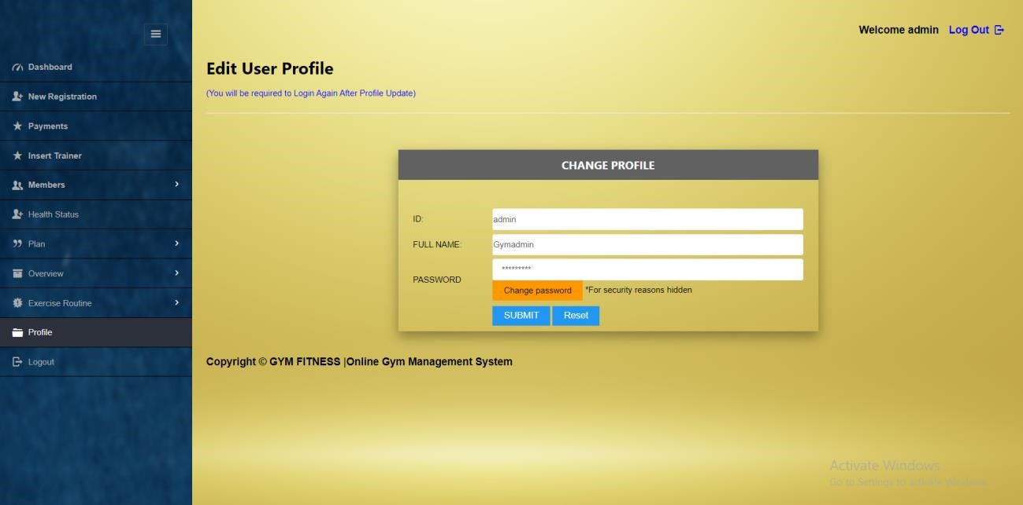

**User Login:**



**User Dashboard:**

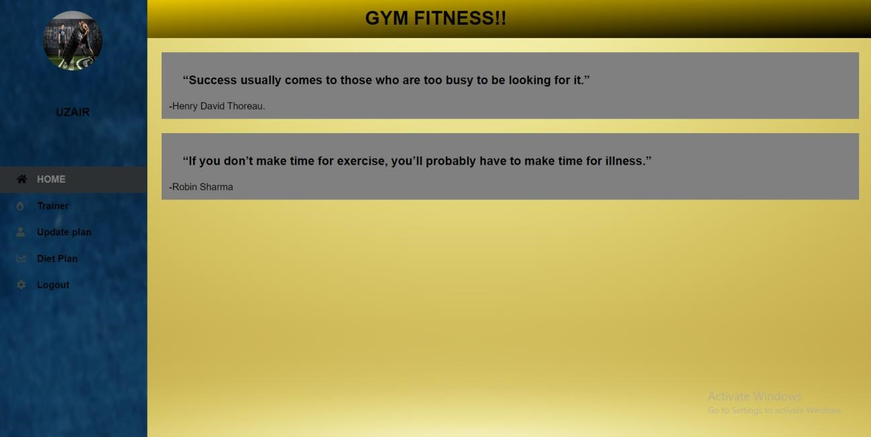

**User Diet Plan:**

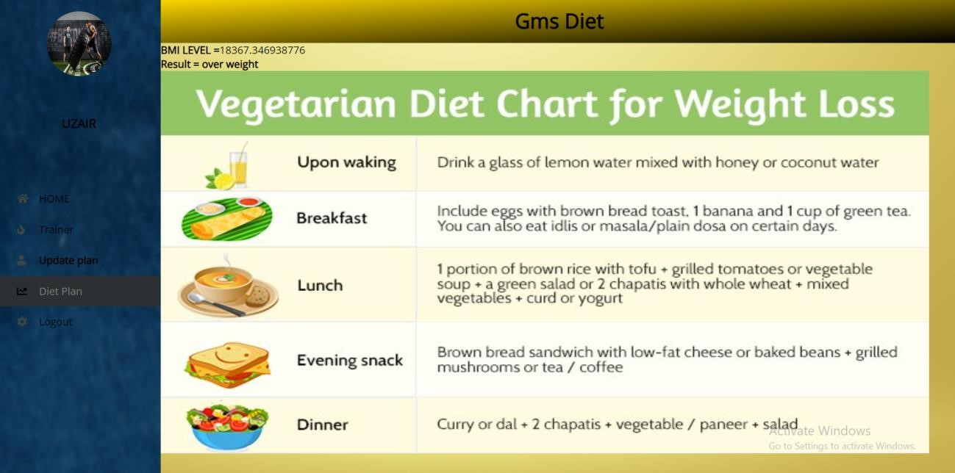

**User subscription plan:**

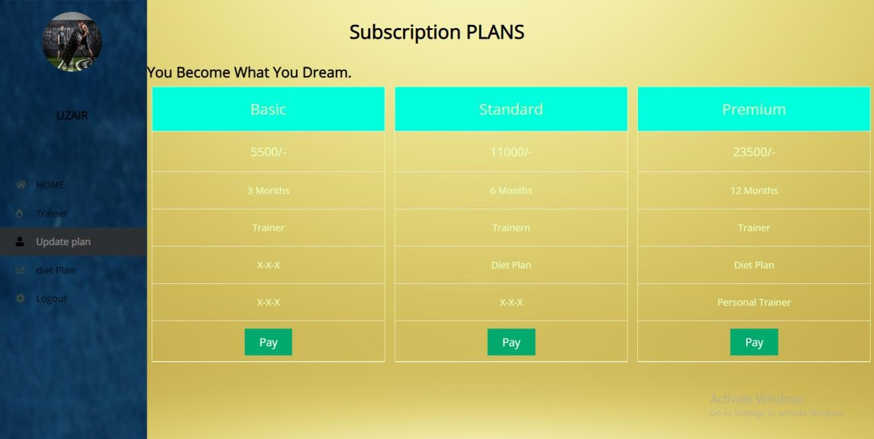

**Assigned trainers:**

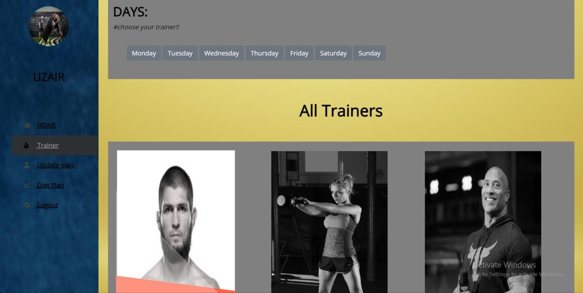

**5. TEST CASES:**

* **Admin Panel Functionality Test Cases:**

|  |  |  |  |  |  |  |
| --- | --- | --- | --- | --- | --- | --- |
| **SL.no** | **Feature** | **Test Case** | | **Expected Outcome** | **Status** | |
| **1.** | Admin Panel  Login | Attempt login with valid credentials  (username/password).  And  Attempt login with invalid credentials. | | Logged into admin panel successfully. and  Authentication error message displayed | **Pass** | |
| **2.** | Customer  Registration | Register a new customer with valid details. | | Customer registered with a unique ID generated. | **Pass** | |
| **3.** | Make Payments | Process a payment for an existing customer. | | Payment processed successfully, transaction details recorded. | **Pass** | |
| **4.** | Maintain  Health Status | Update health status of a customer (e.g., weight, training progress). | | Health status updated and reflected in customer profile. | **Pass** | |
| **5.** | Create and  Manage Plans | Create a new training plan for customers. | | Plan created and assignable to customers. | **Pass** | |
| **6.** | Overall Reports | Generate a report of customer details and admin activities. | | Detailed report generated and accessible to admin. | **Pass** | |
| **7.** | Manage  Routines | Create a new exercise routine for a customer. | | Routine created and visible to assigned customers. | **Pass** | |
| **8.** | Insert Trainer | Add a new gym trainer and assign to a customer. | Trainer added and successfully assigned to customer. | | | **Pass** | |
| **9.** | Admin Profile | View and edit admin profile details.  and  Change admin login credentials  (password/username). | Profile details displayed; able to edit and save changes.  and  Credentials updated successfully; able to login with new credentials. | | | **Pass** | |

* **User Panel Functionality Test Cases:**

|  |  |  |  |  |
| --- | --- | --- | --- | --- |
| **SL.no** | **Feature** | **Test Case** | **Expected Outcome** | **Status** |
| **1.** | User Panel Login | Login with valid user credentials.  and  Login with invalid user credentials. | Logged into user panel successfully.  and  Authentication error message displayed. | **Pass** |
| **2.** | Assigned Trainers | View images of assigned trainers. | Images of assigned trainers displayed next to their profiles. | **Pass** |
| **3.** | Diet Plan | View assigned diet plan and exercise charts. | Diet plan and exercise charts displayed according to user's profile. | **Pass** |
| **4.** | Subscription Plan | Update subscription plan  (e.g., upgrade/downgrade). | Plan updated successfully; confirmation message displayed. | **Pass** |

1. **CONCLUSION AND FUTURE ENHANCEMENT:**
   1. **CONCLUSION:**

In conclusion, the admin panel offers a robust suite of features designed to efficiently manage various aspects of the system, ensuring security, personalized care, and streamlined operations. From secure login and customer registration to payment management, health tracking, and plan creation, every function is geared towards enhancing user experience and organizational efficiency. Detailed reports and profile management further contribute to informed decision-making and system customization. Similarly, the user panel prioritizes security and user empowerment, with features like trainer selection, diet plan access, and subscription management. The mention of visual representations for trainer-user assignments underscores the commitment to user-friendly design and clarity. Overall, both panels reflect a dedication to meeting user needs while upholding the highest standards of functionality and security.

* 1. **FUTURE ENHANCEMENT:**
* Real-time chat Bot option for members and trainers, so that members can directly enquiry theirs trainer on any time through the chat BOT.
* Automated fitness suggestions by enquiring the condition of the health.
* Video conversation option for trainers and members.

1. **BIBILIOGRAPHY:** 
   1. **OVERVIEW OF FRONT-END (HTML/CSS):** 
      * **HTML (HyperText Markup Language):**

HTML provides the structure and content of the web pages in the gym management system. It defines the layout, headings, paragraphs, forms, and other elements that make up the user interface.

**Overview:**

Structuring the web pages to ensure clarity and usability.Creating forms for user input, such as login forms, registration forms, and subscription plan selection forms.Integrating images and multimedia content to enhance the visual experience.Implementing semantic HTML for better accessibility and SEO (Search Engine Optimization).Organizing content hierarchically using headings, lists, and sections.

* + - **CSS (Cascading Style Sheets):**

CSS is responsible for the presentation and styling of HTML elements. It defines the colors, fonts, spacing, layout, and overall visual appearance of the gym management system's frontend.

Overview:

* + - Styling the HTML elements to create a visually appealing and consistent user interface.
    - Implementing responsive design techniques to ensure compatibility across various devices and screen sizes.
    - Using CSS frameworks like Bootstrap or Materialize for rapid development and consistent styling.
    - Applying animations and transitions to enhance user interactions and feedback.
    - Optimizing CSS code for performance and maintainability.
  1. **OVERVIEW OF BACK-END (PHP/SQL):**
     + **PHP (Hypertext Pre-processor):**

PHP is a server-side scripting language used for developing dynamic web applications. In the gym management system, PHP handles the backend logic, data processing, and communication with the database.

**Overview:**

* + - Handling user authentication and authorization, including login and registration processes.
    - Validating user input from forms to prevent security vulnerabilities like SQL injection and cross-site scripting (XSS).
    - Interacting with the database to retrieve, insert, update, and delete data related to customers, trainers, plans, payments, etc.
    - Implementing business logic for features like plan creation, payment processing, routine management, and health status tracking.
    - Integrating with external APIs for functionalities like payment gateways or email notifications.
    - **SQL (Structured Query Language):**

SQL is a standard language for managing relational databases. It is used to define, manipulate, and query the database in the gym management system.

**Overview:**

* + - Designing the database schema to store information about customers, trainers, plans, payments, etc., in a structured format.
    - Creating tables, indexes, and relationships to ensure data integrity and efficiency.
    - Writing SQL queries to retrieve specific data from the database based on user requests or system requirements.
    - Performing CRUD operations (Create, Read, Update, Delete) to manage data within the database.
    - Optimizing SQL queries for performance by using indexes, proper joins, and query optimization techniques.

Overall, the frontend and backend components work together to create a seamless user experience in the gym management system, with HTML/CSS handling the presentation layer and PHP/SQL managing the backend logic and data storage.

**About the Platform:**

Windows is a series of Operating Systems developed by Microsoft. Each version of Windows includes a Graphical User Interface, with a desktop that allows users to view files and folders in Windows. For the past two decades, Windows has been the most widely used operating system for personal computers PCs.

Microsoft Windows is designed for both home computing and professional purposes. Past versions of Windows home editions include Windows 3.0 (1990), Windows 3.1 (1992), Windows 95 (1995), Windows 98 (1998), Windows Me (2000), Windows XP (2001), and Windows Vista (2006). The current version, Windows 7, was released in 2009.

The first business-oriented version of Windows, called Windows NT 3.1, was in 1993. This was followed by Windows 3.5, 4.0, and Windows 2000. When Microsoft released Windows XP in 2001, the company simply created different editions of the operating system for personal and business purposes.

Windows Vista and Windows 7 have followed the same release strategy. Windows is designed to run on standard x86 hardware, such as Intel and AMD processors. Therefore, it can be installed on multiple brands of hardware, such as Dell, HP, and Sony computers, as well as home-built PCs. Windows 7 also includes several touch screen features, that allow the operating system to run on certain tablets and computers with touch screen display

**7.3 WEB REFERENCES:**

<https://www.w3schools.com/w3css/4/w3.css> <https://api.web3forms.com/submit/> <https://fonts.googleapis.com/css?family=Lato><https://fonts.googleapis.com/css?family=Raleway:400,700> <https://cdnjs.cloudflare.com/ajax/libs/font-awesome/4.7.0/css/font-awesome.min.css>